**Climate Change Scepticism Debate – Teachers’ Guide**

This is a guide to the ‘Climate Change Scepticism’ activity. It will help you to understand why this is an important topic to address in the classroom and help you to make the most of the materials provided.

Contents:

1. Scepticism in the classroom: Why should we teach young people about climate change scepticism?

2. Aims of the activities: What are the learning outcomes?

3. The ‘Great Debate’: Instructions, guide to the activity and useful web links

4. Suggested follow-up activities

Scepticism in the Classroom:

Why should we teach young people about Climate Change Scepticism?

Climate change has been an important topic for many years. It is important for students to understand the changes to our climate and why they are happening, not only so that they understand what is going on in the world, but so that they will want to play a part in making decisions about energy use in the future. However, ‘climate change sceptics’ may contradict these ideas. Some sceptics’ ideas are reasonable, many aren’t. Whilst science is all about questioning and testing ideas (all scientists are sceptics!), some media give an unbalanced view of scientific opinion. This may lead to confusion about what they have learnt in school and this is why it is important to ensure that young people are skilled in research and critical thinking so that they can make up their own minds and form their own thoughts, based on facts and evidence.

Researching information for the debate should give all students a better understanding of climate change science, even if they don’t necessarily believe the arguments they are putting forward!

Aims of the activities:

What are the learning outcomes?

By the end of these activities, students should:

• Have a solid understanding of the science behind climate change and the impacts being felt around the world.

• Be able to explain the difference between ‘weather’ and ‘climate’, as well as ‘climate change’ and ‘global warming’.

• Understand the meaning of scepticism, who sceptics are and where they are found.

• Understand that science is all about testing ideas, using evidence.

• Draw on critical thinking skills about what they hear or read in the media.

• Be prepared for a class debate by researching their side of an argument and organizing it into a way that is suitable to present to the class.

The Great Debate: Instructions and guide to the debate activity

It is advised that you are familiar with the materials and content before teaching these activities. These activities are designed for Key Stage 3 pupils (11-14 years) but could be adapted for use for older audiences, too. Ideally, the activities would run over a few lessons, although this is not essential.

The relevant files which you will require are:

• Climate Change Scepticism PowerPoint.ppt

• 2 Debate Cards

It would be useful to have:

• A computer projector and whiteboard

• Flip-charts and marker pens

• Access to computers with the internet

1. In the first session, go through the power-point presentation, taking time to ensure that all key words and phrases are understood, and asking the students to give explanations or opinions. This will refresh their knowledge on climate change, introduce them to the idea of scepticism and introduce the debate activity. It would be good for the class to take some notes.

2. Divide the class into 2 equal groups. Do this randomly. Choose one group to be the ‘climate scientists’ and the other to be ‘the climate sceptics’, giving each group a debate card.

3. Brief the teams separately on their side of the arguments, running through the cards with them. They should divide themselves into 3 groups, each group researching the arguments for/ against one of the three main sceptic arguments. The pupils should be allotted time to research their side of the argument (using the school library and the web-links provided on the bottom of the cards in the following lesson, or other available resources). The way that you organize this is up to you. They should gather as many points and as much evidence to support their side of the argument as possible**. All sides of the argument must be based on facts and evidence, not opinions.**

4. Whilst the pupils are doing their research, it would be a helpful to check regularly on what they are doing, throwing in questions and encouraging them to all get involved and organize their findings into bullet points or brainstorm onto a large poster sized sheet of paper. The background information below might help with this.

5. If you feel the pupils are able, introduce the idea of the ‘hot seat’. The ‘hot seat’ can be used in a debate to ask an individual pupil questions. The students could take on a character and answer questions from the point of view of their character (rather than from themselves). For example, a pupil could act as a child from the Solomon Islands at risk of flooding, an oil industry boss or an MP whose main interest is in how the country is running right now, and the others could ask them questions about their opinion on climate change.

6. Once the pupils are prepared with research and fully understand their side of the argument, then organize the debate. Nominate 5 or 6 pupils from each team to be the spokespeople for their side. Could another teacher (or someone from the school’s debating club, if there is one, or a sixth former, or… ) to be the chair for the debate, guiding the discussion? The bigger the debate becomes, and the more that are involved, the better.

Have someone keeping a record of the points that are raised in the debate is useful – it might be worth designing a scoring system in advance. After the debate is over, end with a discussion to summarize what the students have learned. If there is an audience, ask the them to raise their hands after the debate to see which side they agree with. Recommended discussion points are;

• Who had the most evidence?

• Which points did the students find most interesting?

• Did anyone change their mind about which side they personally stood on (not which side they were on for the debate)?

• Who do I agree with?

Useful links

<https://climatekids.nasa.gov/kids-guide-to-climate-change/>

<http://www.skepticalscience.com> - excellent website to explain sceptic arguments and scientific contradictions and its related game; [Cranky Uncle](https://crankyuncle.com/).

<https://youtu.be/SN5-DnOHQmE?feature=shared> NASA introduction to climate change

The Debate Cards

The debate cards have some useful information for the students to use and will guide them in the right direction on the sorts of things they should be thinking about. The cards also mention that it would be useful for the students to think about the arguments that the other team might use, in order to devise a comeback to those arguments.

**Group 1 – Climate Scientists**

The students in this group should get a good overview of climate science, and do some research on how to respond to the arguments put forward by the other groups.

<http://www.bbc.co.uk/news/science-environment-26814737> - viewpoints

<http://www.isthishowyoufeel.com/this-is-how-scientists-feel.html>

<http://www.skepticalscience.com>

Chris Field – an optimist

"We can use approaches to managing climate change as a way to build a better world, a world that is more robust, more secure, more vibrant.

"I think climate can help us find the best part of ourselves. I think that there are opportunities to capitalize on it, and one of the things we need to do is open our eyes to the balances.

"If we're dumb, it's a serious, serious problem, and if we are smart it a serious problem, but one that we can manage."

**Group 2 – Climate Change ‘Sceptics’**

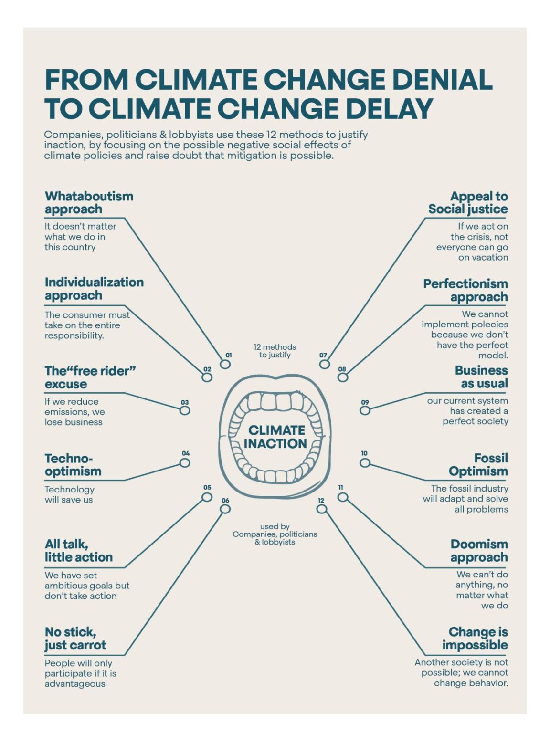

Shared by [**EFFEKT**](EFFEKT) and based on <https://www.cambridge.org/core/journals/global-sustainability/article/discourses-of-climate-delay/7B11B722E3E3454BB6212378E32985A7>

This group is arguing that we don’t need to worry about climate change. They could focus on three main points of argument:

1) Climate change is all natural.

This is the hardest position to be in, as very few people now do not accept the IPCC statement that it is extremely likely that human activities caused more than half of the observed increase in global mean surface temperature from 1951 to 2010.

Some people to look out for

Richard Lindzen, a Professor of Meteorology at the prestigious MIT University in the USA, said in 2009 (<https://skepticalscience.com/skeptic_Richard_Lindzen.htm>)

“Based on the weak argument that the current models used by the IPCC couldn't reproduce the warming from about 1978 to 1998 without some forcing, and that the only forcing that they could think of was man. Even this argument assumes that these models adequately deal with natural internal variability—that is, such naturally occurring cycles as El Niño, the Pacific Decadal Oscillation, the Atlantic Multidecadal Oscillation, etc.

Yet articles from major modeling centers acknowledged that the failure of these models to anticipate the absence of warming for the past dozen years was due to the failure of these models to account for this natural internal variability. Thus even the basis for the weak IPCC argument for anthropogenic climate change was shown to be false.”

John Clauser <https://skepticalscience.com/clauser-latest-climate-denying-physicist.html>

There is a list of arguments which have been used at <http://www.skepticalscience.com/argument.php?f=taxonomy>

Students could present some of the arguments from this list – if only to see whether the other groups have discovered the responses!

Students in this group should get a good overview of climate change science. If the group 1 does its research well, this group should not be able to win the debate!

2) Man-made climate change is happening, but we don’t know enough about what is going to happen to make it worth doing anything to prevent it.

Even in terms of what will happen globally, there is a reasonable amount of uncertainty. However, what people really care about is what is going to change where they are, i.e. regionally or locally. Scientists can’t say that very well yet at all.

Some politicians and economists would argue that if we don’t know whether we need to build a flood barrier to cope with a 10cm or a 1m rise in sea level, is it worth the expense of building a barrier at all?

The costs of mitigating (preventing) or adapting to climate change are high – students could compare the cost of a petrol or electric car or similar, and then go on to consider what the timescales or costs associated with new power stations, new aircraft designs, new building designs etc. might be.

Many scientists would argue that, whatever happens in the next few decades, we should be taking measures now to prevent future climate change, as it will be much cheaper in the long term, and because there may be some aspects of climate change that we, and nature, cannot adapt to at any cost.

<https://www.newscientist.com/round-up/climate-knowns-unknowns/>

For the UK, the UKCP projections give an overview of what we are expecting to see in the UK <https://www.metoffice.gov.uk/binaries/content/assets/metofficegovuk/pdf/research/ukcp/ukcp18_headline_findings_v4_aug22.pdf>

Students researching this topic should learn about uncertainty.

3) Man-made climate change is happening but that people will be able to cope without any special measures being put in place now.

On the whole, the arguments are based on the ability of more affluent societies to survive, and do not consider poorer countries or nature. They also only consider fairly small changes in climate and do not consider probable longer term changes.

Names to look for (some of these people present better arguments than others):

Nigel Lawson, Politician

“There are plainly both advantages and disadvantages from a warmer temperature, and these will vary from region to region depending to some extent on the existing temperature in the region concerned. And it is helpful in this context that the climate scientists believe that the global warming they expect from increased atmospheric CO2 will be greatest in the cold polar regions and least in the warm tropical regions, and will be greater at night than in the day, and greater in winter than in summer. Be that as it may, studies have clearly shown that, overall, the warming that the climate models are now predicting for most of this century is likely to do more good than harm.”

<https://skepticalscience.com/skeptic_Nigel_Lawson.htm>

Bjorn Lomborg, Economist

<https://youtu.be/4TmeRU_L0mo?feature=shared>

Places to look

<https://skepticalscience.com/global-warming-positives-negatives.htm> ”

Follow-up activities

Further activities to complement the debate

• Poster on Climate Change Scepticism: The students could design a poster to explain some of the sceptic arguments and the science.

This resource was originally developed by the team at the Climate Change Schools Project